ST. LUKE’S METHODIST CHURCH
Resurrection Sunday and Holy Communion

April 5th, 2026 __________ __ ________8:30 am

If able, we stand to praise the Lord

PRELUDE

WELCOME & ANNOUNCEMENTS

CALL TO WORSHIP
For this perishable body must put on imperishability,
and this mortal body must put on immortality.
When this perishable body puts on imperishability,
and this mortal body puts on immortality,
then the saying that is written will be fulfilled:
“Death has been swallowed up in victory.”

Where, O death, is your victory?
Where, O death, is your sting?

OPENING HYMN “Christ the Lord Is Risen Today” Hymnal #302

OPENING PRAYER

Almighty God,
Through your only Son you overcame death
and opened to us the gate of everlasting life.
Grant that we who celebrate our Lord’s resurrection,
by the renewing of your Spirit,
arise from the death of sin to the life of righteousness;
through the same Jesus Christ our Lord.
Amen.

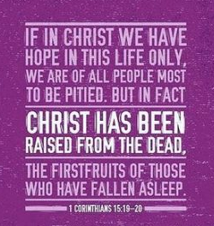
SCRIPTURE READING
1 Corinthians 15:12-20

Liturgist:
This is the word of the Lord.

People: Thanks be to God.

PRAYER
THE LORD’S PRAYER
OFFERTORY

SPECIAL MUSIC “God So Loved” © 2017 Hillsong Music Sung by David Cherry

DOXOLOGY “Praise God, from Whom All Blessings Flow” Hymnal #95

SCRIPTURE LESSON Luke 24:1-12

MESSAGE “The Greatest Day in Human History” Pastor Dan Gedman

THE NICENE CREED Hymnal # 880

HOLY COMMUNION (see insert)

HYMN “Because He Lives" Hymnal #364

BENEDICTION

POSTLUDE

Assisting in Worship: Carrie Soldano (Liturgist)/ Mitchell Griffith & Chris Soldano (Ushers)/ Lenore Retzolk & Gerry Glime (Greeters)

Prayer Concerns

Pray for those in our parish & community needing healing and comfort:
Paisley Grace (and Jeff & Tiffany Brown, grandparents), Jon Smith, Howard Muir, Chris Wright, Bob Bickling, Phyllis Frase, Bette Shull, Christina Thomas, Francis Blazejak, Betty Wheedleton, Darren Cohee, Tom & Betty Barwick, Randy Bowen, Wendy Bradley, Bill Hughes, Kathy, James & Wendy Miller, Cori Bennington, Randall Butler, Hilliard Gardner, Mary Hawkins, Rosemary Ayers, Glenn & Elaine Orme, Kurt Plinke, Mariah Farmer-Grace, Mitchell Griffith, John and Danielle Stewart, Robin, Dave & Jan Almquist, Carol & Lester, Courtney Harrison, Bryan & Addy Flaherty, Terry Benson, Jimmy Tolson, Kitty Patrick, Craig Little, Baby Charlie, Emily Parry, Suzanne Drury, Mary Grace Cheezum, Shawn Parks, Ryan Alexander, Evelyn, and Jason Lee.

Pray in Sympathy for the family and friends of those who have died, especially Phil Maloney.

Pray for those serving in the U.S. Military: Seth Gill, Gabe Griffith, Ethan Lister, Teagan Lister, Andrew Robbins, Jack Schroeder, Bryan Hatch, Brayden Boartes, and Cody Chambers.

This Week at St. Luke’s _____ _ _ _______April 5th - April 12th
Sunday: 8:30 am & 10:00 am Resurrection Sunday Worship & Communion
9:30 am – Adult Sunday School – Room 1
9:45 am – Sunday School – Gather in the Sanctuary
Monday: 10:00 am & 7:00 pm – Book of John Bible Study – Room 1
Office Closed for Easter Monday
Thursday: 10:00 am – OMLG – Room 1
Saturday: 9:00 am – Emmaus Prayer & Fellowship – Hospitality Room
Sunday: 8:30 am & 10:00 am Worship (3rd Graders get bibles @ 10am)
9:30 am – Adult Sunday School – Room 1
9:45 am – Sunday School – Gather in the Sanctuary

Attendance & Stewardship
10:00 am - 140
Sunday School Children: 44 Adults: NA
Offerings: $7894.30

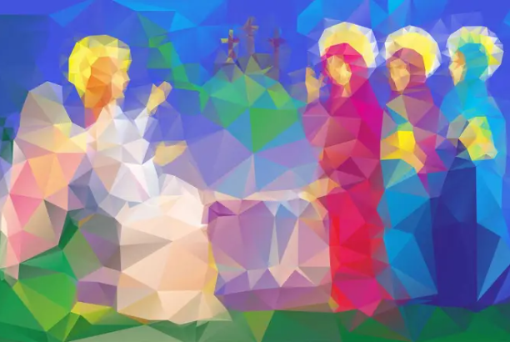


St. Luke’s Methodist Church
A Global Methodist Church

100 S. 5th Avenue, Denton, Maryland 21629

The Reverend Daniel Gedman, Pastor

Garrett Shull, Director of Youth Ministries
Carrie Soldano, Administrative Assistant
Alicia Weippert, Director of Ignite Praise Band
Alex Penn, Nursery Coordinator

Church Office: 410-479-2171
Pastor Dan: 443-693-3694
Email: stlukesdenton@gmail.com
Website: www.stlukesdenton.org

