**ST. LUKE’S METHODIST CHURCH**

**Tenth Sunday after Pentecost**

**August 17th, 2025 __________ ____________ __________8:30 am**

**✞** *If able, we stand to praise the Lord*

**PRELUDE**

**WELCOME & ANNOUNCEMENTS**

✞ **CALL TO WORSHIP** Psalm 145:1-2

I will exalt you, my God the King;

I will praise your name for ever and ever.

**Every day I will praise you**

**and extol your name for ever and ever.**

**✞ OPENING HYMN** “O Worship the King” Hymnal #73

**✞ OPENING PRAYER**

**Heavenly Lord,**

**your name is wonderful and glorious.**

**We come to your presence in the unity of faith**

**to ask for the infilling of your power,**

**for without your power we can do nothing.**

**We pray that your glory radiates in our lives**

**as we your ambassadors live out the days of our lives.**

**Let none of us here go empty handed.**

**Go with us in the service and make it a fulfilling time in your presence.**

**In Jesus’ name we pray. AMEN.**

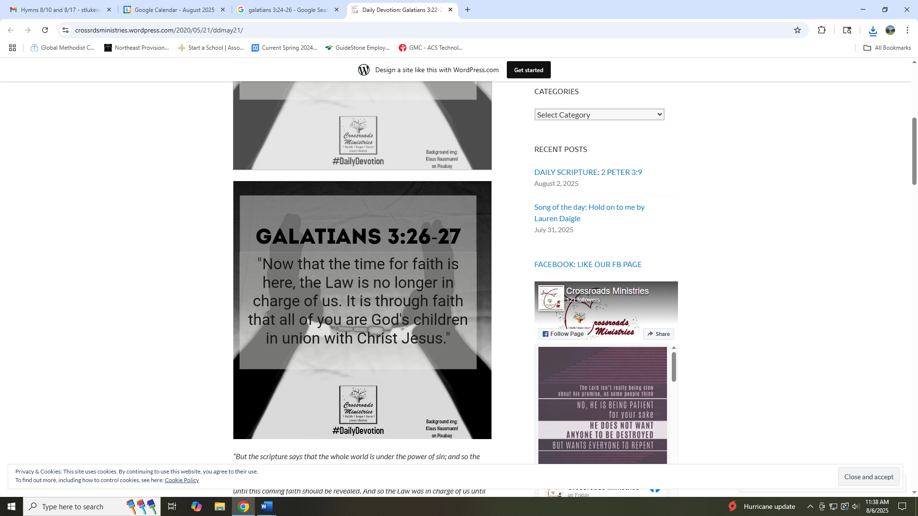

**✞ SCRIPTURE READING**

Galatians 3:21-29

Liturgist:

This is the word of the Lord.

**People: Thanks be to God.**

**PRAYER**

**THE LORD’S PRAYER**

**OFFERTORY**

**✞ DOXOLOGY**  “Praise God From Whom All Blessings Flow” Hymnal **#** 95

**SCRIPTURE LESSON** Romans 5:12-21

**MESSAGE**  Pastor Dan Gedman

**✞ HYMN** “Standing on the Promises” Hymnal #374

**✞ BENEDICTION**

**POSTLUDE**

**Assisting in Worship:** Betty Wheedleton (Liturgist)/ Chris Soldano (Usher)/ Elaine Orme and Carrie Soldano (Greeters)/ Joan Wolff (Pianist)

**Prayer Concerns**:

*Pray for those in our parish & community needing healing and comfort*:

Daniel Farmer-Grace, Janet Boecker, Terrell, Rachel Cordry, Ron Glime, Stacey Pindell, Melva Slonin, Ryan Alexander, Ellen Parker, Bill Medford, Evelyn, Christina Thomas, Mitchell Griffith, Brenda Hayman, Brayden Boartes, Justin Gray, Kevin Douglas-Little, Cory Bennington, Kenny Colley, Joe Little, James Miller, Helen Vogt, Ellie Nguyen, Cristy Russell, Billy Medford, Fred Burton, Craig Little, Jane Thomas, George Lacy, Virginia Liddell, Julie Pursley, Baby Ezra, Renee Barringer, Patsy Biggers, Betty Barwick, Michael Mumford, Patty Downes, Jason Lee, and Mary Lynn Meloni.

*Pray for* our leadership at St. Luke’s Methodist Church and in the Global Methodist Church, that our leaders will be guided by the Holy Spirit to proclaim and follow Christ boldly in word and deed.

*For those serving in the U.S. Military:* Seth Gill, Gabe Griffith, Ethan Lister, Teagan Lister, Andrew Robbins, Jack Schroeder, and Bryan Hatch.

**This Week at St. Luke’s _____ ____ ______ August 17th – August 24th**

Sunday: 8:30 am & 10:00 am Worship

9:30 am – Adult Sunday School – Room 1

Tuesday: 6:30 pm – Young Life Prayer Night - NCHS

Wednesday: 7:00 pm – Praise Band Practice

Thursday: 6:30 pm - Leadership Team Meetings

7:30 pm – Church Council – Room 1

Sunday: 8:30 am & 10:00 am Worship

9:30 am – Adult Sunday School – Room 1

**Attendance & Stewardship Last Sunday**

8:30 am – 40 10:00 am - 64

Needed Weekly: $4,300.00

Offerings: $3,584.40

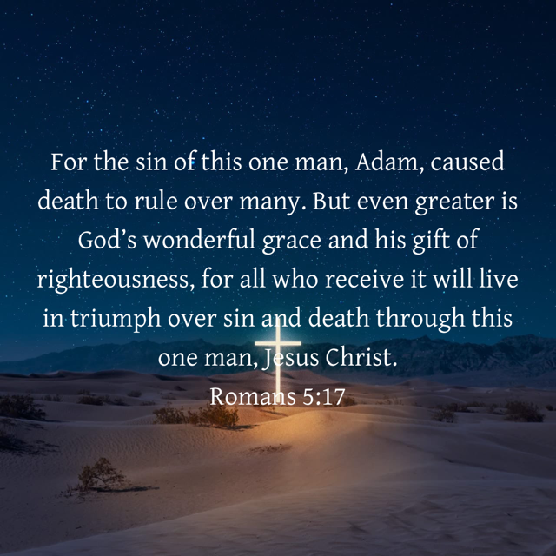



**St. Luke’s Methodist Church**

***A Global Methodist Church***

100 S. 5th Avenue, Denton, Maryland 21629

**The Reverend Daniel Gedman, Pastor**

Garrett Shull, Director of Youth Ministries

Carrie Soldano, Administrative Assistant

Alicia Weippert, Director of Ignite Praise Band

Alex Penn, Nursery Coordinator

**Church Office: 410-479-2171**

**Pastor Dan: 443-693-3694**

**Email:** [***stlukesdenton@gmail.com***](mailto:stlukesdenton@gmail.com)

**Website: *www.stlukesdenton.org***