ST. LUKE’S METHODIST CHURCH

Second Sunday of Advent and Holy Communion

December 7th, 2025 ________ ____________ _______ _8:30 am

If able, we stand to praise the Lord
PRELUDE

WELCOME & ANNOUNCEMENTS

CALL TO WORSHIP Psalm 85:8-13
I will listen to what God the Lord says;
he promises peace to his people, his faithful servants—
but let them not turn to folly.
Surely his salvation is near those who fear him,
that his glory may dwell in our land.
Love and faithfulness meet together;
righteousness and peace kiss each other.
Faithfulness springs forth from the earth,
and righteousness looks down from heaven.
The Lord will indeed give what is good,
and our land will yield its harvest.
Righteousness goes before him
and prepares the way for his steps.

ADVENT WREATH-LIGHTING AND MEDITATION

OPENING HYMN “O For a Thousand Tongues to Sing” Hymnal #57
(Verses 1,2,3,5,6)

OPENING PRAYER

Merciful God, you sent your messengers the prophets to preach repentance and prepare the way for our salvation. Give us grace to heed their warnings and forsake our sins, that we may greet with joy the coming of Jesus Christ, our Redeemer; who lives and reigns with you and the Holy Spirit, one God, now and for ever. Amen.

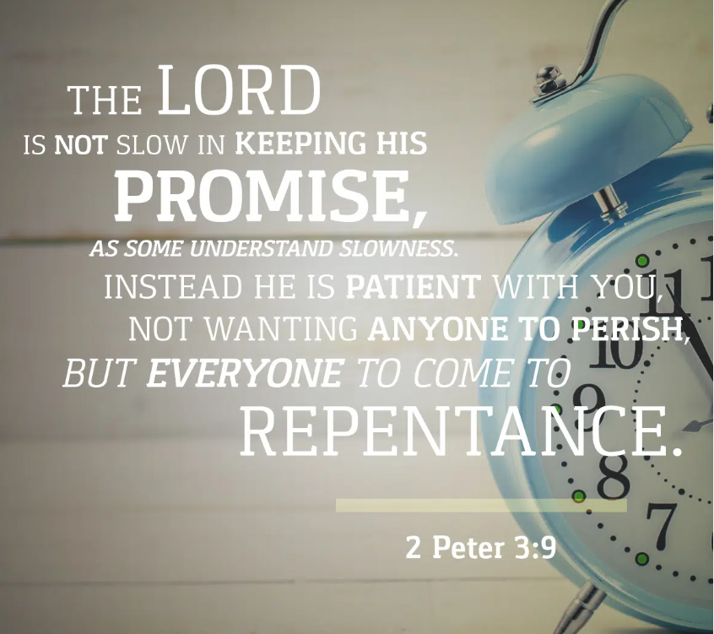

SCRIPTURE READING
2 Peter 3:8-13

Liturgist:
This is the word of the Lord.

People: Thanks be to God.

PRAYER
THE LORD’S PRAYER
OFFERTORY

DOXOLOGY “Praise God From Whom All Blessings Flow” Hymnal # 95

SCRIPTURE LESSON Luke 4:16-21
MESSAGE Pastor Dan Gedman
THE APOSTLES’ CREED Hymnal #881
HOLY COMMUNION (see insert)
HYMN “Hark! the Herald Angels Sing” Hymnal #240
BENEDICTION
POSTLUDE

Assisting in Worship: Carrie Soldano (Liturgist)/ Mitchell Griffith & Chris Soldano (Ushers)/ Gerry Glime & Lenore Retzolk (Greeters)/ Cindy Nicklin & Jim Orr (Advent Readers & Candle Lighting)

Prayer Concerns:

Pray for those in our parish & community needing healing and comfort:
Bob and Ruth Ann Breeding, Cricket & Glenn Williams, Dave & Jan Almquist, George Lacy, Alicia Weippert, Glenn Orme, Meredith Connar, Julia Beaven, Carol & Lester, DCDC, Courtney Harrison, Charlie Poukish, Barbara Little, Bryan & Addy Flaherty, Jimmy Tolson, Jane Thomas, Kitty Patrick, Ava Thomas, Lisa Gardner, Britney Collison, Craig Little, Barbara Lawrence, Baby Charlie, John Webster, Emily Parry, Suzanne Drury, John and Danielle Stewart, Mary Grace Cheezum, Shawn Parks, Ray & Mary Claytor, Ryan Alexander, Ellen Parker, Evelyn, Mitchell Griffith, Brenda Hayman, Justin Gray, Kevin Douglas-Little, James Miller, Virginia Liddell, Patsy Biggers, Michael Mumford, Jason Lee, and Mary Lynn Meloni.

Pray for persecuted Christians in Nigeria and around the world, and for missionaries in Nigeria like Michell Harper, all who stand firm in their faith despite facing suffering and loss.

Pray for the family and friends of those who have died, especially Jim Truitt, Edgar lee Todd, and Marvin Bolt.

Pray for those serving in the U.S. Military: Seth Gill, Gabe Griffith, Ethan Lister, Teagan Lister, Andrew Robbins, Jack Schroeder, and Bryan Hatch.

This Week at St. Luke’s _____ ____ ______________ Dec. 7th – Dec. 14th
Sunday: 8:30 am & 10:00 am – Worship Services – Communion
9:30 am – Adult Sunday Class – Room 1
9:45 am – Sunday School – Gather in Sanctuary
5:00 pm – Lite Fare Refreshments – Fellowship Hall
6:00 pm – Livestream Handel’s “Messiah” – Fellowship Hall
Monday: 6:00 pm – Annual Church Conference - Sanctuary
Wednesday: 7:00 pm – Praise Band Practice
Thursday: 10:00 am – OMG – Room 1
6:30 pm – School Exploratory Committee – Room 1
Saturday: 9:00 am – Redemption Alleyway Coat Give-Away – Fellowship Hall
9:00 am – Emmaus Prayer & Fellowship – Hospitality Room
Sunday: 9:45 am – Sunday School – Gather in Room 1
10:00 am – Worship Service & Sunday School Christmas Program- Sanctuary

Attendance & Stewardship Last Sunday
8:30 am – 57 10:00 am – 71
Sunday School Children: 50 Adults: 13
Needed Weekly: $4,300.00
Offerings Last Week: $2,958.28

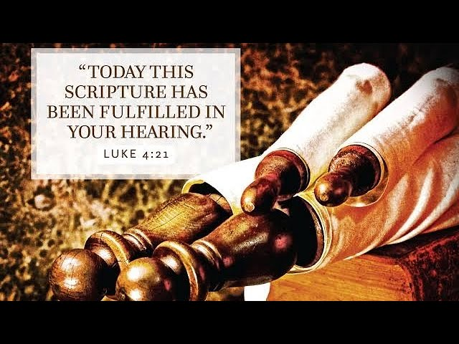


St. Luke’s Methodist Church

A Global Methodist Church

100 S. 5th Avenue, Denton, Maryland 21629

The Reverend Daniel Gedman, Pastor

Garrett Shull, Director of Youth Ministries
Carrie Soldano, Administrative Assistant
David Cherry, Music Director Traditional Service
Alicia Weippert, Director of Ignite Praise Band
Alex Penn, Nursery Coordinator

Church Office: 410-479-2171
Pastor Dan: 443-693-3694
Email: stlukesdenton@gmail.com
Website: www.stlukesdenton.org

