ST. LUKE’S METHODIST CHURCH
Second Sunday after the Resurrection

April 12th, 2026 __________ __ ________8:30 am

If able, we stand to praise the Lord
PRELUDE

WELCOME & ANNOUNCEMENTS

CALL TO WORSHIP Psalm 143:8

Let the morning bring me word of your unfailing love,
for I have put my trust in you.
Show me the way I should go,
for to you I entrust my life.

OPENING HYMN “Up from the Grave He Arose” Hymnal #322

OPENING PRAYER

Lord God, in a world
where truth seems so relative,
your Word is a solid foundation;
where love is but a flickering, momentary flame,
your passion is a constant ember;
where power is widely abused,
your quiet strength works for justice;
where law is enforced from the outside in,
your rule is from the inside out;
where peace is misunderstood as an absence of conflict,
your reconciliation is a voice of calm amid the storm;
where joy depends upon outer circumstance,
your happiness is an ever-flowing spring from within.
As we sing your praise, Awesome God, Father, Son, and Holy Spirit,
we open ourselves to you.
Abide in us. Help us to abide in you as we worship you this hour.
In Jesus’ name we pray. Amen.

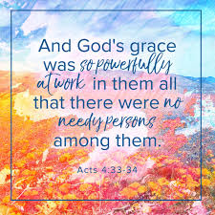

SCRIPTURE READING
Acts 4:32-35

Liturgist:
This is the word of the Lord.

People: Thanks be to God.

PRAYER
THE LORD’S PRAYER
OFFERTORY “Festival Piece on ‘Rejoice Ye Pure in Heart’” Messiter/Gilbert Martin

DOXOLOGY “Praise God, from Whom All Blessings Flow” Hymnal #95

SCRIPTURE LESSON Luke 24:36-49

MESSAGE Pastor Dan Gedman

HYMN “Thine Be the Glory” Hymnal #308

BENEDICTION

POSTLUDE

Assisting in Worship: Cindy Nicklin (Liturgist)/ Tom Barwick (Ushers)/ Elaine Orme & Carrie Soldano (Greeters); Becky Zinser (Piano & Organ)

Prayer Concerns

Pray for those in our parish & community needing healing and comfort:
Jacki Poore, Paisley Grace (and Jeff & Tiffany Brown, grandparents), Don Smith, Howard Muir (and his family) Chris Wright, Bob Haught, Phyllis Frase, Bette Shull, Christina Thomas, Francis Blazejak, Darren Cohee, Tom & Betty Barwick, Randy Bowen, Wendy Bradley, Bill Hughes, James & Wendy Miller, Cori Bennington, Randall Butler, Hilliard Gardner, Mary Hawkins, Rosemary Ayers, Glenn & Elaine Orme, Kurt Plinke, Mariah Farmer-Grace, Mitchell Griffith, John and Danielle Stewart, Robin, Dave & Jan Almquist, Carol & Lester, Courtney Harrison, Bryan & Addy Flaherty, Terry Benson, Jimmy Tolson, Kitty Patrick, Craig Little, Baby Charlie, Emily Parry, Suzanne Drury, Mary Grace Cheezum, Shawn Parks, Ryan Alexander, Evelyn, and Jason Lee.

Pray in Sympathy for the family and friends of those who have died, especially Bob Bickling.

Pray for those serving in the U.S. Military: Seth Gill, Gabe Griffith, Ethan Lister, Teagan Lister, Andrew Robbins, Jack Schroeder, Bryan Hatch, Brayden Boartes, and Cody Chambers.

This Week at St. Luke’s _____ _ _ _______April 12th - April 19th
Sunday: 8:30 am & 10:00 am Worship (3rd Grade Bibles)
9:30 am – Adult Sunday School – Room 1
9:45 am – Sunday School – Gather in the Sanctuary
Monday: 10:00 am & 7:00 pm – Book of John Bible Study – Room 1
Thursday: 10:00 am – OMLG – Room 1
7:30 pm – Church Council – Room 1
Sunday: 8:30 am & 10:00 am Worship (Confirmation)
9:30 am – Adult Sunday School – Room 1
9:45 am – Sunday School – Gather in the Sanctuary

Attendance & Stewardship
8:30 am – 94 10:00 am - 129
Sunday School Children: 51 Adults: 14
Offerings: $6,176.30

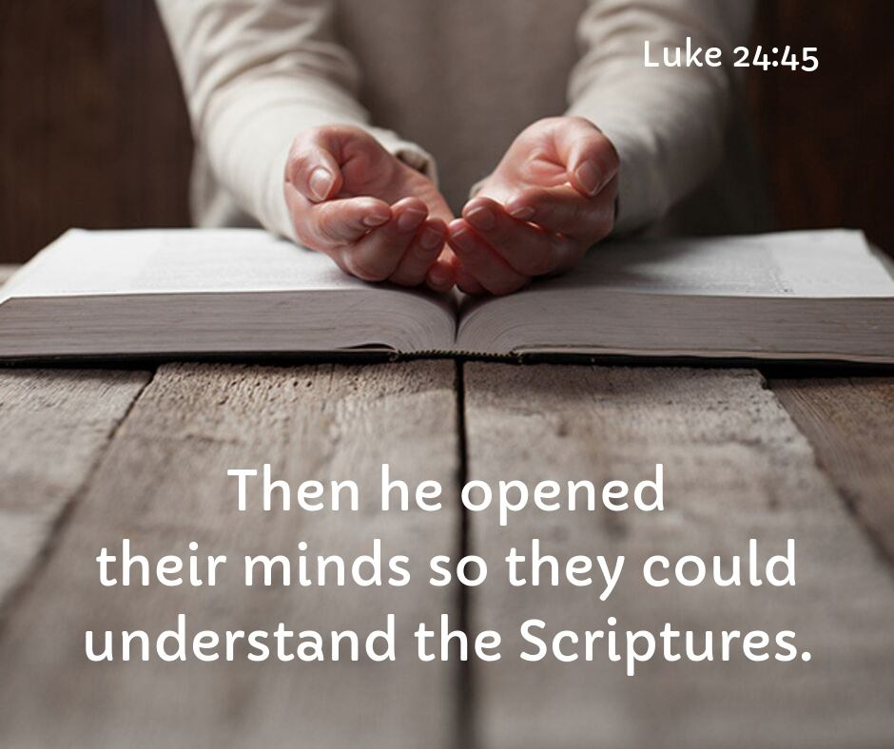


St. Luke’s Methodist Church
A Global Methodist Church

100 S. 5th Avenue, Denton, Maryland 21629

The Reverend Daniel Gedman, Pastor

Garrett Shull, Director of Youth Ministries
Carrie Soldano, Administrative Assistant
Alicia Weippert, Director of Ignite Praise Band
Alex Penn, Nursery Coordinator

Church Office: 410-479-2171
Pastor Dan: 443-693-3694
Email: stlukesdenton@gmail.com
Website: www.stlukesdenton.org

