**ST. LUKE’S METHODIST CHURCH**

**Nineteenth Sunday after Pentecost**

**October 19th, 2025 ________ ____________ _______ _8:30 am**

**✞** *If able, we stand to praise the Lord*

**PRELUDE**

**WELCOME & ANNOUNCEMENTS**

**CALL TO WORSHIP** Psalm 33:4-5

For the word of the Lord is right and true;

**he is faithful in all he does.**

The Lord loves righteousness and justice;

**the earth is full of his unfailing love.**

**✞ OPENING HYMN** “Cry of My Heart” TFWS #2165

**✞ OPENING PRAYER**

**Father in heaven,**

**you alone are worthy of all our praises.**

**We come together and raise our voices in praise**

**for your wondrous works in our lives.**

**Accept our thanksgiving in Jesus**

**for we are the work of your hands.**

**You are the one true God.**

**Come and manifest yourself in our midst today.**

**We know in your word that without you we can do nothing;**

**come and empower us to do all things for you in Jesus’ name. Amen.**

**

**✞ SCRIPTURE READING**

*Galatians 2:17-21*

Liturgist:

This is the word of the Lord.

**People: Thanks be to God.**

**PRAYER**

**THE LORD’S PRAYER**

**OFFERTORY**

**✞ DOXOLOGY**  “Praise God From Whom All Blessings Flow” Hymnal **#** 95

**SCRIPTURE LESSON** *Revelation 2:18-29*

**MESSAGE** Pastor Dan Gedman

**✞ HYMN** “Crown Him with Many Crowns” Hymnal #327

**✞ BENEDICTION**

**POSTLUDE**



The flowers on the altar are given by

Mitchell and Margaret Griffith

to the Glory of God

and in remembrance of our sons

Barry Lee and Dary Kirt.

**Assisting in Worship:** Cathy Brice (Liturgist)/ Ron Glime (Usher)/ Barbara Little & Margaret Griffith (Greeters)

**Prayer Concerns**:

*Pray for those in our parish & community needing healing and comfort*:

Kitty Patrick, Ava Thomas, Julia Beaven, Sharon Slaughter, Courtney Harrison, Lindsay, Marvin Bolt, Merry Lee Beaven, Lisa Gardner, Maddie Gedman, Shaun & Atrea Burke, Britney Collison, Craig Little, Barbara Lawrence, Dottie Branson, Baby Charlie, Mariah Farmer-Grace, Glenn Orme, John Webster, Emily Parry, Suzanne Drury, John and Danielle Stewart, Lisa Loring, Mary Grace Cheezum, Shawn Parks, Ray & Mary Claytor, Ryan Alexander, Ellen Parker, Bill Medford, Evelyn, Mitchell Griffith, Brenda Hayman, Justin Gray, Kevin Douglas-Little, Kenny Colley, James Miller, Fred Burton, George Lacy, Virginia Liddell, Patsy Biggers, Betty Barwick, Michael Mumford, Jason Lee, and Mary Lynn Meloni.

*Pray for our leadership* at St. Luke’s Methodist Church and in the Global Methodist Church, that our leaders will be guided by the Holy Spirit to proclaim and follow Christ boldly in word and deed.

*Pray for those serving in the U.S. Military:* Seth Gill, Gabe Griffith, Ethan Lister, Teagan Lister, Andrew Robbins, Jack Schroeder, and Bryan Hatch.

**This Week at St. Luke’s _____ ____ _______________ Oct. 19th – Oct. 26th**

Sunday: 8:30 am & 10:00 am – Worship Services

9:30 am – Adult Sunday Class – Room 1

9:45 am – Sunday School – Gather in Sanctuary

Monday: 10:00 am & 7:00 pm – James Bible Study – Room 1

Wednesday: 7:00 pm – Praise Band Practice

Thursday: 10:00 am – OMG Old Men’s Group – Room 1

Sunday: 9:45 am – Sunday School – Gather in Room 1

**10:00 am – Anniversary & New Member Worship Service Sanctuary**

**11:00 am – Lite Fare Reception – Fellowship Hall**

**Attendance & Stewardship Last Sunday**

8:30 am – 43 10:00 am – 67

Sunday School Children: 46 Adults: 11

Needed Weekly: $4,300.00

Offerings Last Week: $3,852.40

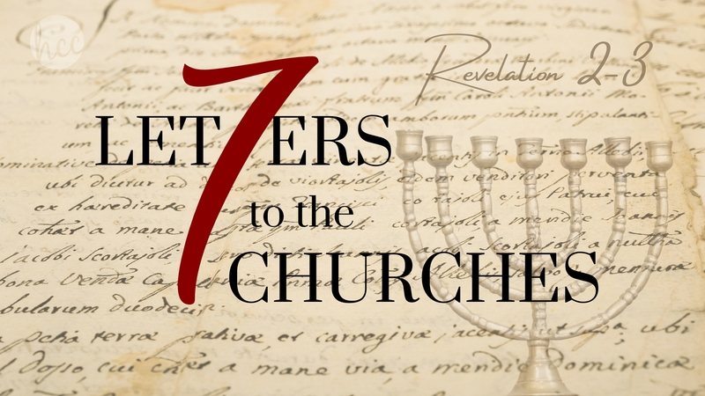

**St. Luke’s Methodist Church**

***A Global Methodist Church***

100 S. 5th Avenue, Denton, Maryland 21629

**The Reverend Daniel Gedman, Pastor**

Garrett Shull, Director of Youth Ministries

Carrie Soldano, Administrative Assistant

David Cherry, Music Director Traditional Service

Alicia Weippert, Director of Ignite Praise Band

Alex Penn, Nursery Coordinator

**Church Office: 410-479-2171**

**Pastor Dan: 443-693-3694**

**Email:** [***stlukesdenton@gmail.com***](mailto:stlukesdenton@gmail.com)

**Website: *www.stlukesdenton.org***