ST. LUKE’S METHODIST CHURCH

Third Sunday of Advent
and The Sunday School Christmas Program

December 14th, 2025 ____________________________ 10:00 am

If able, we stand to praise the Lord

PRELUDE

WELCOME & ANNOUNCEMENTS

LIGHTING OF THE ADVENT WREATH

CALL TO WORSHIP Psalm 126:1-3

When the Lord restored the fortunes of Zion,
we were like those who dreamed.
Our mouths were filled with laughter,
our tongues with songs of joy.
Then it was said among the nations,
“The Lord has done great things for them.”
The Lord has done great things for us,
and we are filled with joy.

OPENING HYMN “Good Christians Friends, Rejoice” Hymnal #224
OPENING PRAYER

O God, you so loved the world as to give your only begotten son,
that whosoever believes in him should not perish,
but have everlasting life.
Grant to us the precious gift if faith,
that we may know that the Son of God is come,
and may have power to overcome the world
and gain a blessed immortality;
through Jesus Christ our Lord. Amen.

SCRIPTURE READING John 1:6-8, 19-28
PRAYER
THE LORD’S PRAYER
OFFERTORY

DOXOLOGY


THE SUNDAY SCHOOL
CHRISTMAS PROGRAM
(see insert)

Hymns the congregation sings during program

“Away in a Manger” (1st verse) Hymnal #217
“Angels We Have Heard on High” (1st verse) Hymnal #238
“Silent Night” (3rd verse after soloists) Hymnal #239
“Joy to the World” (1st verse) Hymnal #246

CLOSING HYMN “Go Tell It On the Mountain” Hymnal # 251

BENEDICTION

POSTLUDE

Assisting in Worship: Tom Barwick, Donnie & Sherry Baker (ushers); Garrett Shull and the Youth Group (Advent Candles & Meditation); Elaine Orme & Carrie Soldano (Greeters)
Prayer Concerns:

Pray for those in our parish & community needing healing and comfort:
Ziggy Zurek-Wellen, Robin, Bob and Ruth Ann Breeding, Dave & Jan Almquist, Alicia Weippert, Glenn Orme, Meredith Connar, Julia Beaven, Carol & Lester, DCDC, Courtney Harrison, Charlie Poukish, Barbara Little, Bryan & Addy Flaherty, Jimmy Tolson, Jane Thomas, Kitty Patrick, Ava Thomas, Lisa Gardner, Craig Little, Barbara Lawrence, Baby Charlie, John Webster, Emily Parry, Suzanne Drury, John and Danielle Stewart, Mary Grace Cheezum, Shawn Parks, Ryan Alexander, Ellen Parker, Evelyn, Mitchell Griffith, Brenda Hayman, Justin Gray, James Miller, Virginia Liddell, Patsy Biggers, Michael Mumford, and Jason Lee..

Pray for persecuted Christians in Nigeria and around the world, and for missionaries in Nigeria like Michell Harper, all who stand firm in their faith despite facing suffering and loss.

Pray for the family and friends of those who have died, especially Jim Truitt, Edgar lee Todd, and Marvin Bolt.

Pray for those serving in the U.S. Military: Seth Gill, Gabe Griffith, Ethan Lister, Teagan Lister, Andrew Robbins, Jack Schroeder, and Bryan Hatch.

This Week at St. Luke’s _____ ____ ______________ Dec. 14th – Dec. 21st
Sunday: 9:45 am – Sunday School – Gather in Room 1
10:00 am – Worship Service & Sunday School Christmas Program
Tuesday: 6:30 pm – Church Safety Committee – Room 1
Wednesday: 7:00 pm – Praise Band Practice
Thursday: 10:00 am – OMG – Room 1
Sunday: 8:30 am & 10:00 am – Worship Services – Communion
9:30 am – Adult Sunday Class – Room 1
9:45 am – Sunday School – Gather in Sanctuary

Attendance & Stewardship Last Sunday
8:30 am – 53 10:00 am – 71
Sunday School Children: 56 Adults: 13
Needed Weekly: $4,300.00
Offerings Last Week: $14,156.00

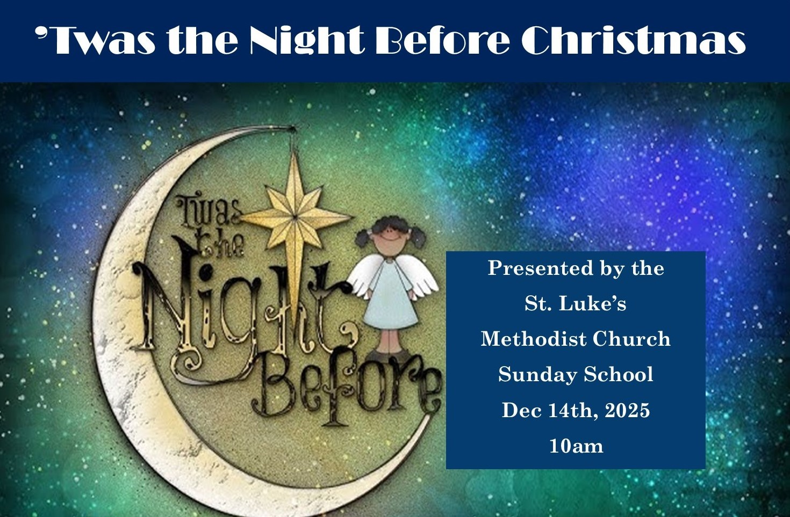


St. Luke’s Methodist Church

A Global Methodist Church

100 S. 5th Avenue, Denton, Maryland 21629

The Reverend Daniel Gedman, Pastor

Garrett Shull, Director of Youth Ministries
Carrie Soldano, Administrative Assistant
David Cherry, Music Director Traditional Service
Alicia Weippert, Director of Ignite Praise Band
Alex Penn, Nursery Coordinator

Church Office: 410-479-2171
Pastor Dan: 443-693-3694
Email: stlukesdenton@gmail.com
Website: www.stlukesdenton.or

