ST. LUKE’S METHODIST CHURCH
4th Sunday of Easter

April 21, 2024 __________ ________8:30 am and 11:00 am

If able, we stand to praise the Lord

PRELUDE

WELCOME & ANNOUNCEMENTS

CALL TO WORSHIP Psalm 97:1-2
The Lord reigns, let the earth be glad;
let the distant shores rejoice.
Clouds and thick darkness surround him;
righteousness and justice are the foundation of his throne.

OPENING HYMN “Great Is Thy Faithfulness ” Hymnal #140
OPENING PRAYER

O God, our resurrection & life,
the promise of your new life in Christ
is like a breath of fresh air in a dry and thirsty land.
We have gathered as believers,
and as those who are honestly seeking the truth.
Guide our worship this hour. AMEN.

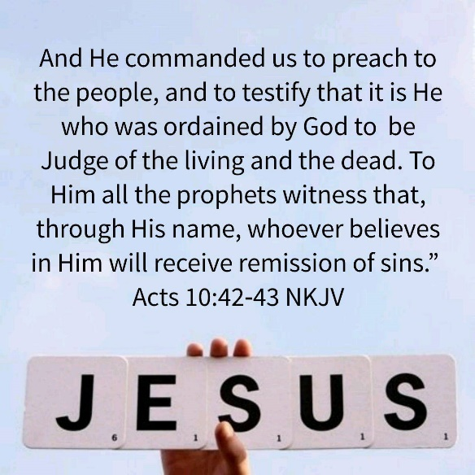

SCRIPTURE READING
Acts 10:39-43

Liturgist:
This is the word of the Lord.

People: Thanks be to God.

PRAYER
THE LORD’S PRAYER
OFFERTORY

DOXOLOGY “Praise God, from Whom All Blessings Flow” Hymnal #95

SCRIPTURE LESSON John 20:24-31

MESSAGE “The Resurrection Appearances of Christ” (Part 4) Pastor Dan Gedman
HYMN “I Know Whom I Have Believed” Hymnal #741

BENEDICTION

POSTLUDE

Assisting in Worship this Morning:
8:30 am: Laura Patrick/Garrett Shull 11:00 am: Patti Burton/Chris Soldano

Prayer Concerns:
Sydney Baker, Sylvia Holland, Linda Turner, Lenore Retzolk, Samantha McCall, Wayne Fretterd, Sr., Mike and Brenda Carnes, Conner Callahan, Amelia Cauffman, Ruth Moore, Ed Smith, Renee Barringer, Bruce Hastings, Patsy Biggers, Joyce Bell, John Resdin, Lauren Gedman, Michael Mumford, Elaine Orme, Craig Harris-Little, Cameron White, Patty Downes, Potsy and Kelly Kemp, Jason Lee, Mary Lynn Meloni, Glenn Owen, Kathy Todd, Kim Todd, Glenn and Cricket Williams, and Owen Wise.

In sympathy to the family and friends of Patricia Herb and Matthew Blue.

For those serving in the U.S. Military: Chelsea Bunker, Seth Gill, Gabe Griffith, Ethan Lister, Teagan Lister, Matthew Parker, Andrew Robbins, and Jack Schroeder.

This Week at St. Luke’s _____ _ _________ April 21st – April 28th
Sunday: 8:30 am, 9:40 am & 11:00 am, Worship Services
9:30 am, Children’s Chapel, Choir, & Sunday School
9:30 am, MS/HS Class, Library
9:30 am, Adult Sunday Class, Room 1
Monday: 5:30 pm, Exercise Class, 2nd Floor
Tuesday: 7:00 pm, Praise Band Practice, FH
Wednesday: 12:00 – 6:00 pm, Delmarva Blood Bank
5:30 pm, Exercise Class, 2nd Floor
Sunday: 8:30 am, 9:40 am & 11:00 am, Worship Services
Confirmation at 9:40 service
9:30 am, Children’s Chapel, Choir, & Sunday School
9:30 am, MS/HS Class, Library
9:30 am, Adult Sunday Class, Room 1

Attendance & Stewardship
8:30 am Worship: 28 9:40 am Worship: 45 11:00 am Worship: 13
Needed Weekly: $4,300.00
Giving Last Week: $5,019.40

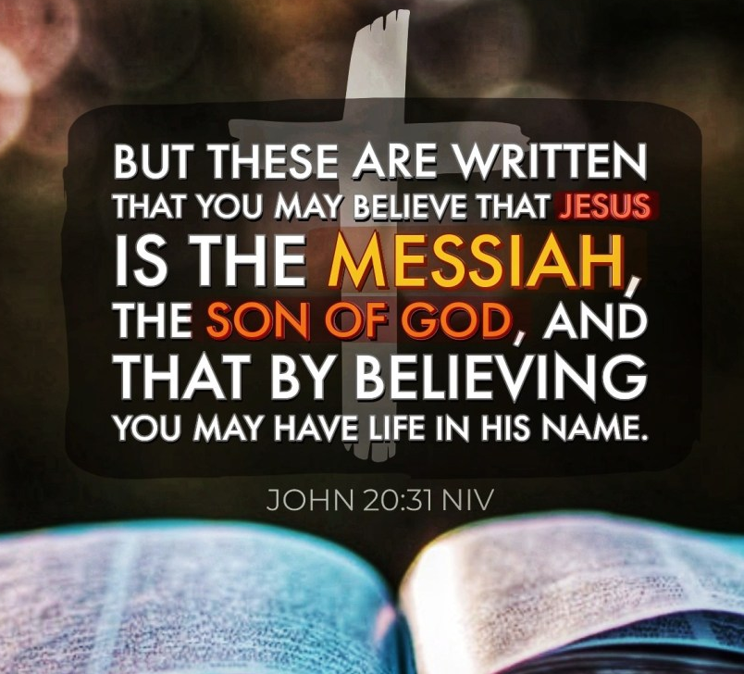
St. Luke’s Methodist Church
A Global Methodist Church

100 S. 5th Avenue, Denton, Maryland 21629

The Reverend Daniel Gedman, Pastor

Garrett Shull, Director of Youth Ministries
Carrie Soldano, Administrative Assistant
Darlene Holliday, Director of Music
Alicia Weippert, Director of Ignite Praise Band
Alex Penn, Nursery Coordinator

Church Office Telephone: 410-479-2171
Pastor Dan’s Cell: 443-693-3694
Church Email: stlukesdenton@gmail.com
St. Luke’s Website: stlukesdenton.org

