ST. LUKE’S METHODIST CHURCH
Independence Sunday and Holy Communion

July 5th, 2026 __________ __ _____ ___8:30 am

If able, we stand to praise the Lord

PRELUDE “Theme and Variation on God Save the King” (“America”) Beethoven

WELCOME & ANNOUNCEMENTS

PLEDGE OF ALLEGIANCE

CALL TO WORSHIP Psalm 67:5-7

May the peoples praise you, God;
may all the peoples praise you.
The land yields its harvest;
God, our God, blesses us.
May God bless us still,
so that all the ends of the earth will fear him.

OPENING HYMN “America the Beautiful” Hymnal #696

OPENING PRAYER

Almighty God, who has given us this good land for our heritage,
we humbly pray that we may always prove ourselves a people mindful
of your many blessings and always striving to do your will.
As we celebrate 250 years of our nation's founding, we pause to consider
not only who we have been, but who we are becoming and who we are called to be.
We are grateful for the ideals expressed in our founding documents—
that all are created equal and endowed with the right to life, liberty,
and the pursuit of happiness.
We pray that you would continue to bestow your Spirit of wisdom and knowledge upon your church as we read and study the Bible
and that we would continue to serve you faithfully in all we think, do and, say.
In Jesus’ name we pray. Amen.

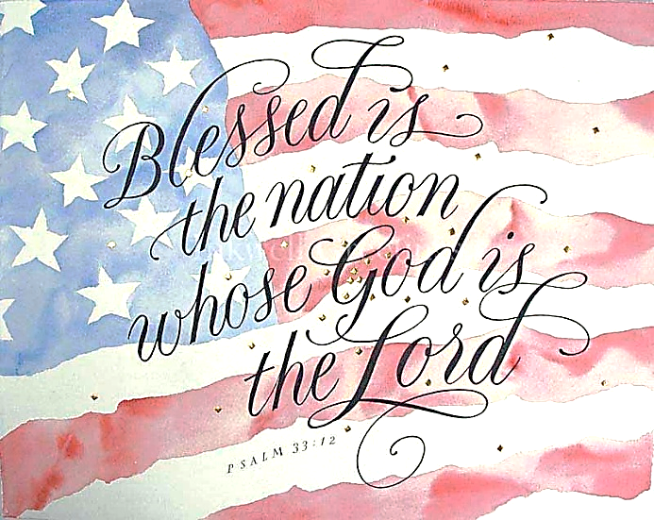

SCRIPTURE READING
Psalm 33:12-22

Liturgist:
This is the word of the Lord.

People: Thanks be to God.

SPECIAL MUSIC “Battle Hymn of the Republic” Arr., Roy Ringwald
Soloists: Jody Herb & John Webster

PRAYER
THE LORD’S PRAYER
OFFERTORY “General Washington’s March” Anonymous

DOXOLOGY “Praise God, from Whom All Blessings Flow” Hymnal #95

SCRIPTURE LESSON Deuteronomy 8:6-10
MESSAGE Pastor Dan Gedman

THE NICENE CREED Hymnal #880

HOLY COMMUNION (see insert)

CLOSING HYMN “This Is My Song Hymnal #437

BENEDICTION

POSTLUDE “Patriotic Medley” Various Composers

Assisting in Worship: Jody Herb (Liturgist)/ Mitchell Griffith & Chris Soldano (Ushers)/ Lenore Retzolk & Gerry Glime (Greeters)

Prayer Concerns

Pray for those in our parish & community needing healing and comfort:
Ron Glime, Barbara Bacsak, Terry Benson, Marie Stewart, Anne Jones, Glenn & Elaine Orme, Sally & John Taylor, Mary Patrick, Laurie Swann, Gary Wise, Kenzie MacLean, Kenny Wood, Don Smith, Chris Wright, Jimmy Tolson, Phyllis Frase, Francis Blazejak, Randy Bowen, Bill Hughes, Rosemary Ayers, Kurt Plinke, Mariah Farmer-Grace, Mitchell Griffith, John and Danielle Stewart, Robin, Dave & Jan Almquist, Carol & Lester, Courtney Harrison, Craig Little, Baby Charlie, Suzanne Drury, and Shawn Parks.

Pray in Sympathy for the family and friends of those who have died, especially Missy Brown.

Pray for those serving in the U.S. Military: Seth Gill, Gabe Griffith, Ethan Lister, Teagan Lister, Andrew Robbins, Jack Schroeder, Bryan Hatch, Brayden Boartes, and Cody Chambers.

This Week at St. Luke’s _____ _ _ _____ July 5th - July 12th
Sunday: 8:30 am & 10:00 am Worship (Communion)
9:30 am – Adult Sunday School – Room 1
Saturday: 9;00 am – Emmaus Prayer & Fellowship – Hospitality Room
Sunday: 8:30 am & 10:00 am Worship
9:30 am – Adult Sunday School – Room 1

Attendance & Stewardship
8:30 am: 41 10:00 am – 65
Adult Sunday School: 15
Offerings: $1588.30

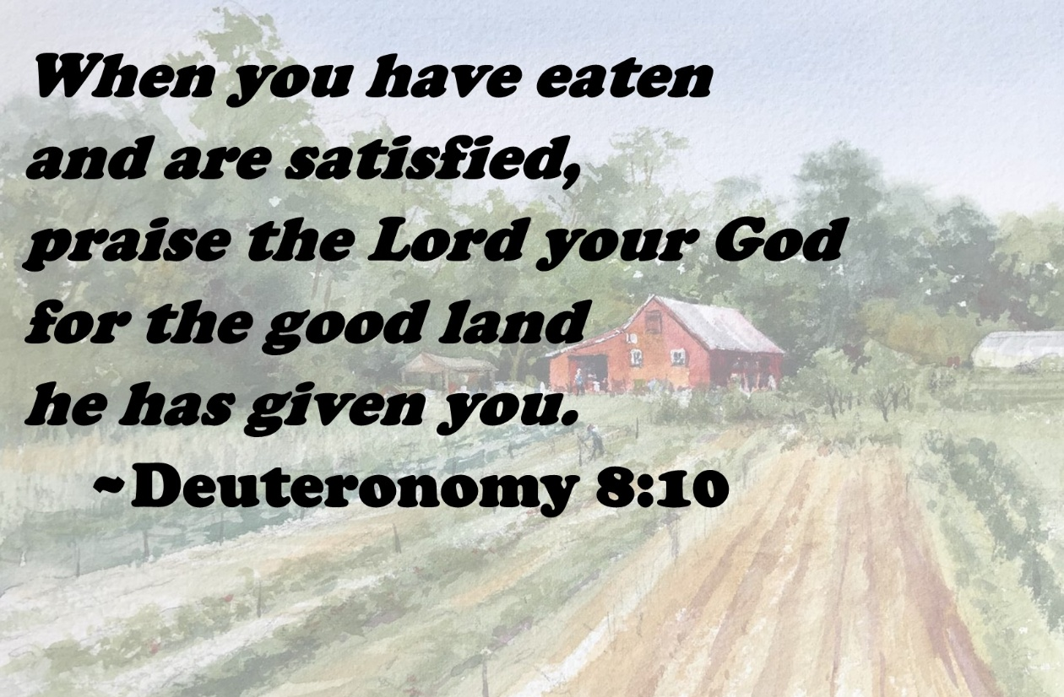


St. Luke’s Methodist Church
A Global Methodist Church

100 S. 5th Avenue, Denton, Maryland 21629

The Reverend Daniel Gedman, Pastor

Garrett Shull, Director of Youth Ministries
Carrie Soldano, Administrative Assistant
David Cherry, Music Director Traditional Service
Alicia Weippert, Director of Ignite Praise Band
Bruce Golt, Maintenance Manager
Alex Penn, Nursery Coordinator

Church Office: 410-479-2171
Pastor Dan: 443-693-3694
Email: stlukesdenton@gmail.com
Website: www.stlukesdenton.or

