ST. LUKE’S METHODIST CHURCH

Fourth Sunday in Lent

March 15th, 2026 __________________ ___ __ 8:30 am

If able, we stand to praise the Lord

PRELUDE

WELCOME & ANNOUNCEMENTS

CALL TO WORSHIP Psalm 115:16-18

The highest heavens belong to the Lord,
but the earth he has given to mankind.
It is not the dead who praise the Lord,
those who go down to the place of silence;
it is we who extol the Lord,
both now and forevermore.
Praise the Lord.

OPENING HYMN “We Bring the Sacrifice of Praise” TFWS #2031

OPENING PRAYER

Everlasting God,
because of your tender mercy toward all people,
you sent your son, our Savior Jesus Christ,
to take upon himself our flesh,
and to suffer death upon the cross,
that all should follow the example of his great humility.
Mercifully grant that we may follow the example of his patience
and also be made partakers of his resurrection;
through the same Jesus Christ our Lord. Amen.

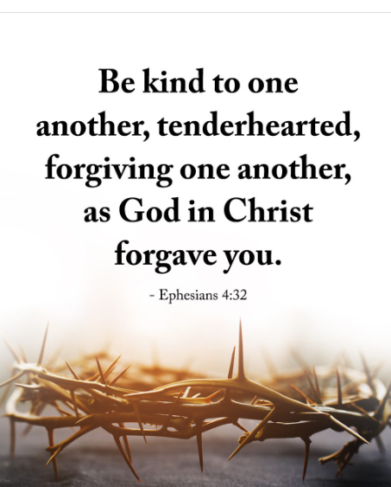
SCRIPTURE READING
Ephesians 4:29- 5:2

Liturgist:
This is the word of the Lord.

People: Thanks be to God.

PRAYER
THE LORD’S PRAYER
OFFERTORY

DOXOLOGY “Praise God From Whom All Blessings Flow” Hymnal # 95

SCRIPTURE LESSON Mark 6:14-29
MESSAGE Pastor Dan Gedman
CLOSING HYMN “Be Thou My Vision” Hymnal #451

BENEDICTION

POSTLUDE

Assisting in Worship: Carrie Soldano (Liturgist); Ron Glime (Usher);
Margaret Griffith & Barbara Little (Greeters)

Prayers of Intersession

Pray for those in our parish & community needing healing and comfort:
Tom & Betty Barwick, Bell-Wilson family, Randy Bowen, Wendy Bradley, Bill Hughes, Kathy, James & Wendy Miller, Wayne Durham, Cori Bennington, Randall Butler, Hilliard Gardner, Mary Hawkins, Rosemary Ayers, Glenn & Elaine Orme, Kurt Plinke, Jennifer Shull, Mariah Farmer-Grace, Mitchell Griffith, John and Danielle Stewart, Brenda Hayman, Robin, Dave & Jan Almquist, Carol & Lester, Courtney Harrison, Bryan & Addy Flaherty, Terry Benson, Jimmy Tolson, Kitty Patrick, Craig Little, Baby Charlie, Emily Parry, Suzanne Drury, Mary Grace Cheezum, Shawn Parks, Ryan Alexander, Evelyn, and Jason Lee.

Pray for peace in our nation, that our national leaders will demonstrate humility and wisdom, and for Christians to have the courage to stand firm in their faith.

Pray in Sympathy for the family and friends of those who have died, especially Liam Madison.

Pray for those serving in the U.S. Military: Seth Gill, Gabe Griffith, Ethan Lister, Teagan Lister, Andrew Robbins, Jack Schroeder, Bryan Hatch, and Brayden Boartes.

This Week at St. Luke’s _____ ____ ______ March 15th – March 22nd
Sunday: 8:30 am & 10:00 am – Worship Services
9:30 am – Adult Sunday Class – Room 1
9:45 am – Sunday School – Gather in Sanctuary
Monday: 10:00 am & 7:00 pm – Bible Study Gospel of John – Room 1
Wednesday: 7:00 pm – Praise Band Practice – Fellowship Hall
Thursday: 10:00 am – OM&LG (Old Men and Ladies Group)– Room 1
7:30 pm – Church Council – Room 1
Friday: 6:00 pm – Lenten Soup Supper – Fellowship Hall
Sunday: 8:30 am & 10:00 am – Worship Services
9:30 am – Adult Sunday Class – Room 1
9:45 am – Sunday School – Gather in Sanctuary
6:30 pm – Lenten Series “The Faces of Jesus” - Sanctuary

Attendance & Stewardship Last Week
8:30 am: 36 10:00 am: 66
Sunday School Students: 42 Adults: 10
Offerings: $5,436.30




St. Luke’s Methodist Church

A Global Methodist Church

100 S. 5th Avenue, Denton, Maryland 21629

The Reverend Daniel Gedman, Pastor

Garrett Shull, Director of Youth Ministries
Carrie Soldano, Administrative Assistant
David Cherry, Music Director Traditional Service
Alicia Weippert, Director of Ignite Praise Band
Alex Penn, Nursery Coordinator

Church Office: 410-479-2171
Pastor Dan: 443-693-3694
Email: stlukesdenton@gmail.com
Website: www.stlukesdenton.or

