ST. LUKE’S METHODIST CHURCH
Tenth Sunday after Pentecost and Holy Communion

August 2nd, 2026 _ __ __ _____ ___ 8:30 am

If able, we stand to praise the Lord

PRELUDE “Give Thanks” (incl. “Now We Thank We All Our God”) Henry Smith/Joel Raney
“Bow Down” (incl “Praise to the Lord Almighty”, O Worship the King” , Praise Him! Praise Him!)

WELCOME & ANNOUNCEMENTS

CALL TO WORSHIP Psalm 19:1:4

The heavens declare the glory of God;
the skies proclaim the work of his hands.
Day after day they pour forth speech;
night after night they reveal knowledge.
They have no speech, they use no words;
no sound is heard from them.
Yet their voice goes out into all the earth,
their words to the ends of the world.

OPENING HYMN “Ask Ye What Great Thing I Know” Hymnal #163

OPENING PRAYER

Oh Lord our God, you reign from everlasting to everlasting.
Your glory is eternal and your grace and mercy abounds within us.
God of heaven, cleanse all our iniquities, make us worthy to be in your presence.
Help us to enjoy all the blessings that come with worshipping you.
Establish us a peculiar nation for your name
and let people see your glory in our lives forever.
In Jesus’ name we pray. Amen.

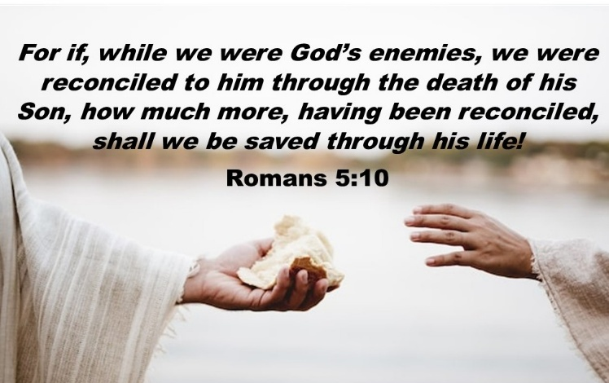

SCRIPTURE READING
Romans 5:6-11

Liturgist:
This is the word of the Lord.

People: Thanks be to God.

SPECIAL MUSIC “Blessings” Story/Sorenson
Soloist: Jody Herb

PRAYER
THE LORD’S PRAYER
OFFERTORY “The King of Love” Baker & Dykes/Young

DOXOLOGY “Praise God, from Whom All Blessings Flow” Hymnal #95

SCRIPTURE LESSON Acts 6:8-15
MESSAGE Pastor Dan Gedman

THE NICENE CREED

HOLY COMMUNION

CLOSING HYMN “For the Bread Which You Have Broken” Hymnal #614

BENEDICTION

POSTLUDE “Hymn to Joy” with “St Anthony’s Choral” Beethoven/K. Lee Scott

Assisting in Worship: Carrie Soldano (Liturgist)/ Mitchell Griffith (Usher)/ Lenore Retzolk & Gerry Glime (Greeters)

Prayer Concerns

Pray for those in our parish & community needing healing and comfort:
George Lacy, Robin Rankin, Tom Barwick, Cathy Brice, Mike Penn, Dr. Ed and Susan Coulston, Terry Benson, Marie Stewart, Anne Jones, Glenn & Elaine Orme, Sally & John Taylor, Laurie Swann, Gary Wise, Kenzie MacLean, Don Smith, Chris Wright, Jimmy Tolson, Phyllis Frase, Francis Blazejak, Randy Bowen, Bill Hughes, Rosemary Ayers, Kurt Plinke, Mariah Farmer-Grace, Mitchell Griffith, John and Danielle Stewart, Robin, Dave & Jan Almquist, Carol & Lester, Courtney Harrison, Craig Little, Baby Charlie, Suzanne Drury, and Shawn Parks.

Pray for those serving in the U.S. Military: Seth Gill, Gabe Griffith, Ethan Lister, Teagan Lister, Andrew Robbins, Jack Schroeder, Bryan Hatch, Brayden Boartes, and Cody Chambers.

This Week at St. Luke’s _____ _ _ _____ August 2nd – August 9th
Sunday: 8:30 am & 10:00 am Worship (Communion)
9:30 am – Adult Sunday School – Room 1
Thursday: 10:00 am – OMLG – Room 1
Sunday: 8:30 am & 10:00 am Worship (Communion)
9:30 am – Adult Sunday School – Room 1

Attendance & Stewardship July 19th
8:30 am: 45 10:00 am: 51
Adult Sunday School: 15
Offerings: $3,708.30

Attendance & Stewardship July 26th
8:30 am: 53 10:00 am: 55
Adult Sunday School: 13
Offerings: $2,082.30
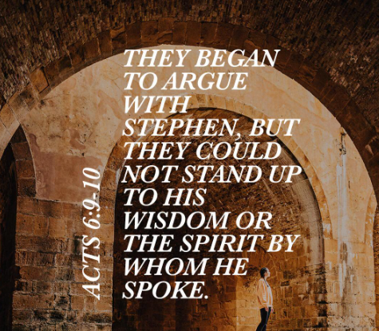


St. Luke’s Methodist Church
A Global Methodist Church

100 S. 5th Avenue, Denton, Maryland 21629

The Reverend Daniel Gedman, Pastor

Garrett Shull, Director of Youth Ministries
Carrie Soldano, Administrative Assistant
David Cherry, Music Director Traditional Service
Alicia Weippert, Director of Ignite Praise Band
Bruce Golt, Maintenance Manager
Alex Penn, Nursery Coordinator

Church Office: 410-479-2171
Pastor Dan: 443-693-3694
Email: stlukesdenton@gmail.com
Website: www.stlukesdenton.or

