ST. LUKE’S METHODIST CHURCH

Thanksgiving Sunday

November 23rd, 2025 ________ ____________ _______ _8:30 am

If able, we stand to praise the Lord

PRELUDE

WELCOME & ANNOUNCEMENTS

CALL TO WORSHIP

Thank you God for the day you give us.
Your love is limitless like the infinite sky.
Your kindness blesses us each morning,
Every evening and even at night.

OPENING HYMN “Since Jesus Came into My Heart” TFWS #2140

OPENING PRAYER

Thank you Lord, for all your blessings to us and our families.
Thank you for the strength you give us each day.
Thank you for our friends and for all the people around us
who make life more meaningful.
Thank you, God, for all these things. Amen.

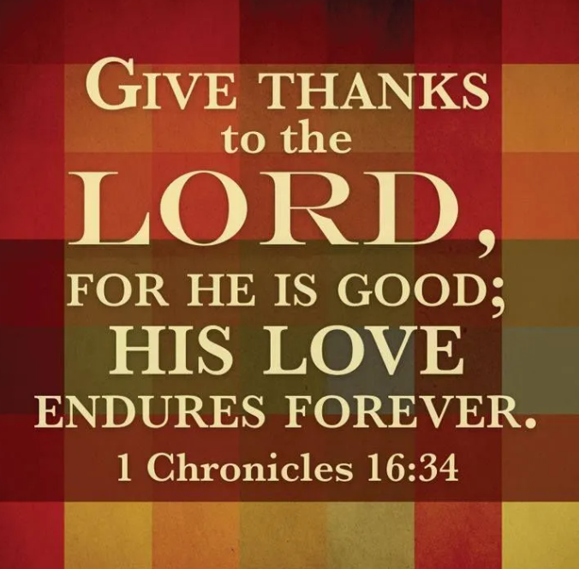
SCRIPTURE READING
1 Chron 16:28-36

Liturgist:
This is the word of the Lord.

People: Thanks be to God.

PRAYER
THE LORD’S PRAYER
OFFERTORY

DOXOLOGY “Praise God From Whom All Blessings Flow” Hymnal # 95

SCRIPTURE LESSON Luke 17:11-19
MESSAGE Garrett Shull
HYMN “Spirit Song” Hymn #347
BENEDICTION
POSTLUDE

Assisting in Worship: Betty Wheedleton (Liturgist)/ Geoffrey & Nikki Young (Ushers)/ Penny Healy, Lily Greenwood, & Gerry Glime (Greeters)

Prayer Concerns:

Pray for those in our parish & community needing healing and comfort:
Alicia Weippert, Glenn Orme, Meredith Connar, Julia Beaven, Keith McMahan, Carol & Lester, DCDC, Charlie Poukish, Barbara Little, Bryan & Addy Flaherty, Jimmy Tolson, Mariah Farmer-Grace, Jane Thomas, Kitty Patrick, Ava Thomas, Sharon Slaughter, Marvin Bolt, Lisa Gardner, Maddie Gedman, Britney Collison, Craig Little, Barbara Lawrence, Baby Charlie, John Webster, Emily Parry, Suzanne Drury, John and Danielle Stewart, Lisa Loring, Mary Grace Cheezum, Shawn Parks, Ray & Mary Claytor, Ryan Alexander, Ellen Parker, Bill Medford, Evelyn, Mitchell Griffith, Brenda Hayman, Justin Gray, Kevin Douglas-Little, Kenny Colley, James Miller, Virginia Liddell, Patsy Biggers, Michael Mumford, Jason Lee, and Mary Lynn Meloni.

Pray for the persecuted Christians in Nigeria and around the world who stand firm in their faith despite facing brutality, ecomonic loss, and even death.

Pray for the family and friends of those who have died, especially Joyce Andrew, Allan McCullough, and Maria Covey.

Pray for those serving in the U.S. Military: Seth Gill, Gabe Griffith, Ethan Lister, Teagan Lister, Andrew Robbins, Jack Schroeder, and Bryan Hatch.

This Week at St. Luke’s _____ ____ _______________ Nov. 23rd – Nov. 30th
Sunday: 8:30 am & 10:00 am – Worship Services
9:30 am – Adult Sunday Class – Room 1
9:45 am – Sunday School – Gather in Sanctuary
Wednesday: 7:00 pm – Praise Band Practice
Thursday: Office Closed for Thanksgiving
Saturday: 9:00 am – Nuts for Sale – Outside Chapel Doors
Sunday: 8:30 am & 10:00 am – Worship Services - 1st Sunday in Advent & REACH
9:30 am – Adult Sunday Class – Room 1
9:45 am – Sunday School – Gather in Sanctuary

Attendance & Stewardship Last Sunday
8:30 am – 51 10:00 am – 68
Sunday School Children: 45 Adults: 13
Needed Weekly: $4,300.00
Offerings Last Week: $4,719.40

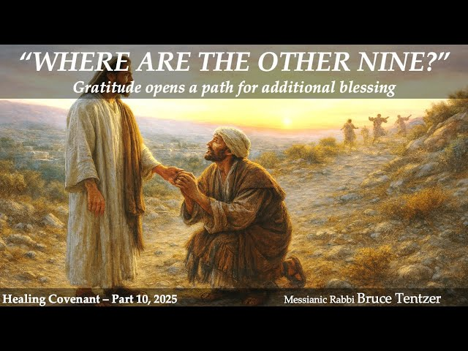


St. Luke’s Methodist Church

A Global Methodist Church

100 S. 5th Avenue, Denton, Maryland 21629

The Reverend Daniel Gedman, Pastor

Garrett Shull, Director of Youth Ministries
Carrie Soldano, Administrative Assistant
David Cherry, Music Director Traditional Service
Alicia Weippert, Director of Ignite Praise Band
Alex Penn, Nursery Coordinator

Church Office: 410-479-2171
Pastor Dan: 443-693-3694
Email: stlukesdenton@gmail.com
Website: www.stlukesdenton.org

