ST. LUKE’S METHODIST CHURCH
Trinity Sunday and outREACH Sunday

May 31st, 2026 __________ __ _____ __10:00 am

If able, we stand to praise the Lord

PRELUDE

WELCOME & ANNOUNCEMENTS

CALL TO WORSHIP Psalm 118:22-24

The stone the builders rejected
has become the cornerstone;
the Lord has done this,
and it is marvelous in our eyes.
The Lord has done it this very day;
let us rejoice today and be glad.

OPENING HYMN “Great Is Thy Faithfulness” Hymnal #140

OPENING PRAYER

Holy God,
You have given us grace,
by the confession of the faith of your holy church,
to acknowledge the mystery of the Eternal Trinity
and, in power of your divine majesty, to worship the Unity.
Keep us steadfast in this faith and worship,
and bring us at last to see in your eternal glory
One God, now and forever. Amen.


SCRIPTURE READING
Matthew 3:13-17

Liturgist:
This is the word of the Lord.

People: Thanks be to God.

PRAYER
THE LORD’S PRAYER
OFFERTORY PRAISE SONG “10,000 Reasons (Bless the Lord)” (see insert for lyrics)

DOXOLOGY “Praise God, from Whom All Blessings Flow” Hymnal #95

SCRIPTURE LESSON Acts 2:13-21

MESSAGE Pastor Dan Gedman

CLOSING PRAISE SONG “My Lighthouse” (see insert for lyrics)

BENEDICTION

POSTLUDE

Assisting in Worship: Tom Connar (Liturgist)/ Tom Barwick & Wayne Fretterd (Ushers)/ Jodie Lindorm & Lenore Retzolk (Greeters)

Prayer Concerns

Pray for those in our parish & community needing healing and comfort:
Glenn & Elaine Orme, Mary Plumley, Kenzie MacLean, Jessica Eaton, Tim Lee, Shannon Hannawald, Kenny Wood, Don Smith, Chris Wright, Jimmy Tolson, Phyllis Frase, Christina Thomas, Francis Blazejak, Randy Bowen, Wendy Bradley, Bill Hughes, Cori Bennington, Randall Butler, Rosemary Ayers, Kurt Plinke, Mariah Farmer-Grace, Mitchell Griffith, John and Danielle Stewart, Robin, Dave & Jan Almquist, Carol & Lester, Courtney Harrison, Kitty Patrick, Craig Little, Baby Charlie, Suzanne Drury, Shawn Parks, and Evelyn.

Pray in Sympathy for the family and friends of those who have died, especially Eunice Howard, Arthur Porter, and Bryan Flaherty.

Pray for those serving in the U.S. Military: Seth Gill, Gabe Griffith, Ethan Lister, Teagan Lister, Andrew Robbins, Jack Schroeder, Bryan Hatch, Brayden Boartes, and Cody Chambers.

This Week at St. Luke’s _____ _ _ _____ __May 31st - June 7th
Sunday: 10:00 am - 5th Sunday Worship – Sanctuary
Tuesday: 6:30 pm – Women of Faith Quarterly Meeting - Chapel
Wednesday: 10:00 am – Cards of Comfort – Hospitality Room
Thursday: 10:00 am – OMLG – Room 1
Sunday: 8:30 am & 10:00 am Worship (Communion & Graduate Sunday)
9:30 am – Adult Sunday School – Room 1

Summer Office Hours (June – August) are Tuesday-Thursday 8:30 am – 5:00 pm

Attendance & Stewardship
8:30 am – 53 10:00 am – 69
Offerings: $2,309.30

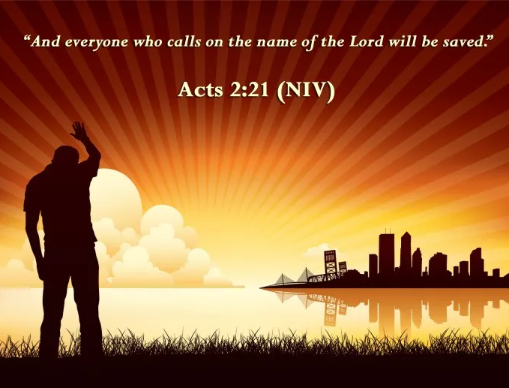


St. Luke’s Methodist Church
A Global Methodist Church

100 S. 5th Avenue, Denton, Maryland 21629

The Reverend Daniel Gedman, Pastor

Garrett Shull, Director of Youth Ministries
Carrie Soldano, Administrative Assistant
David Cherry, Music Director Traditional Service
Alicia Weippert, Director of Ignite Praise Band
Bruce Golt, Maintenance Manager
Alex Penn, Nursery Coordinator

Church Office: 410-479-2171
Pastor Dan: 443-693-3694
Email: stlukesdenton@gmail.com
Website: www.stlukesdenton.or

