ST. LUKE’S METHODIST CHURCH
Second Sunday after Pentecost and Communion
& Graduate Sunday

June 7th, 2026 __________ __ _____ ___8:30 am

If able, we stand to praise the Lord

PRELUDE

WELCOME & ANNOUNCEMENTS

CALL TO WORSHIP Psalm 33:1-4

Sing joyfully to the Lord, you righteous;
it is fitting for the upright to praise him.
Praise the Lord with the harp;
make music to him on the ten-stringed lyre.
Sing to him a new song;
play skillfully, and shout for joy.
For the word of the Lord is right and true;
he is faithful in all he does.

OPENING HYMN “They Will Know We Are Christians by Our Love” TFWS #2223

OPENING PRAYER

Our Father in heaven, King of glory, faithful Father,
we adore your name and glorify you forever.
You promised us that whenever we call upon your name,
you will answer us with your presence.
Come into our midst O God, Father, Son, and Holy Spirit.
Fellowship with us and visit us with your overwhelming presence.
Make your blessings abundant in our worship today.
As we worship you, from the beginning to the end,
glorify yourself and draw us closer to you.
In Jesus’ name we pray. Amen.

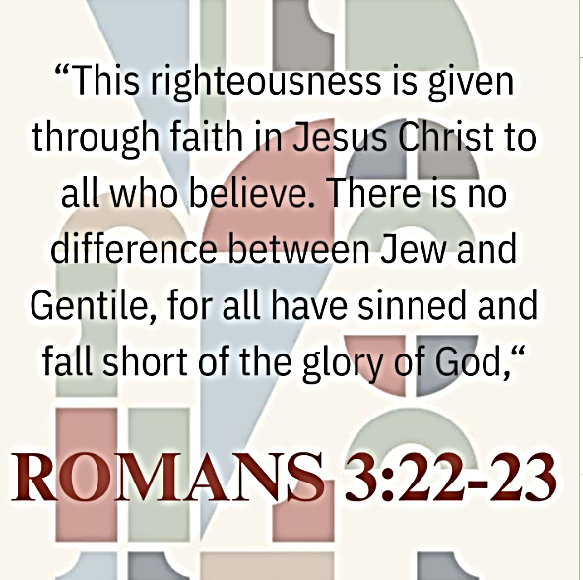
SCRIPTURE READING
Romans 3:21-23

Liturgist:
This is the word of the Lord.

People: Thanks be to God.

RECOGNITION OF GRADUATES
PRAYER
THE LORD’S PRAYER
OFFERTORY

DOXOLOGY “Praise God, from Whom All Blessings Flow” Hymnal #95

SCRIPTURE LESSON Acts 2:22-33

MESSAGE Pastor Dan Gedman

THE NICENE CREED Hymnal #880

HOLY COMMUNION (see insert)

CLOSING HYMN “Lord, I Want to Be a Christian” Hymnal #402

BENEDICTION

POSTLUDE

Assisting in Worship: Tom Barwick (Liturgist)/ Mitchell Griffith & Chuck Dean (Ushers)/ Gerry Glime & Lenore Retzolk (Greeters)

Prayer Concerns

Pray for those in our parish & community needing healing and comfort:
Stacie Bailey, Gary Wise, Glenn & Elaine Orme, Mary Plumley, Kenzie MacLean, Jessica Eaton, Tim Lee, Shannon Hannawald, Kenny Wood, Don Smith, Chris Wright, Jimmy Tolson, Phyllis Frase, Christina Thomas, Francis Blazejak, Randy Bowen, Wendy Bradley, Bill Hughes, Cori Bennington, Randall Butler, Rosemary Ayers, Kurt Plinke, Mariah Farmer-Grace, Mitchell Griffith, John and Danielle Stewart, Robin, Dave & Jan Almquist, Carol & Lester, Courtney Harrison, Kitty Patrick, Craig Little, Baby Charlie, Suzanne Drury, Shawn Parks, and Evelyn.

Pray in Sympathy for the family and friends of those who have died, especially Eunice Howard, Arthur Porter, Bryan Flaherty, Patrice Morrison, and Demair Lloyd.

Pray for those serving in the U.S. Military: Seth Gill, Gabe Griffith, Ethan Lister, Teagan Lister, Andrew Robbins, Jack Schroeder, Bryan Hatch, Brayden Boartes, and Cody Chambers.

This Week at St. Luke’s _____ _ _ _____ __June 7th – June 14th
Sunday: 8:30 am & 10:00 am Worship (Communion & Graduate Sunday)
9:30 am – Adult Sunday School – Room 1
Thursday: 10:00 am – OMLG – Room 1
Saturday: 9:00 am – Emmaus Prayer & Fellowship – Hospitality Room
Sunday: 8:30 am & 10:00 am Worship
9:30 am – Adult Sunday School – Room 1

Summer Office Hours (June – August) are Tuesday-Thursday, 8:30 am – 5:00 pm

Attendance & Stewardship
10:00 am – 97
Offerings: $4,151.30

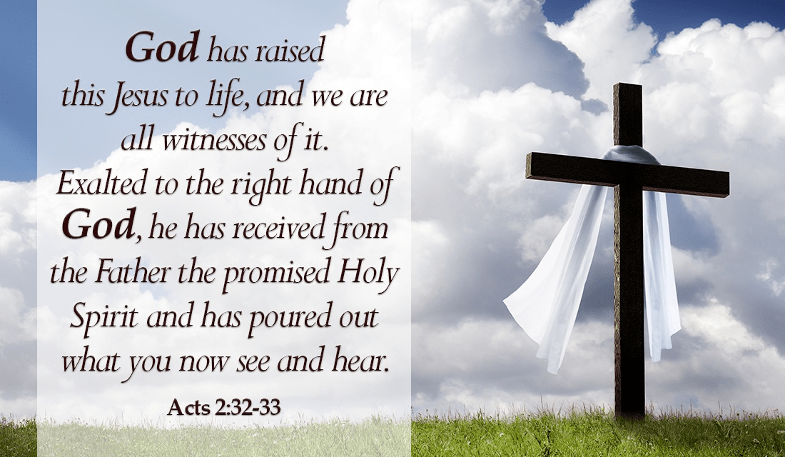


St. Luke’s Methodist Church
A Global Methodist Church

100 S. 5th Avenue, Denton, Maryland 21629

The Reverend Daniel Gedman, Pastor

Garrett Shull, Director of Youth Ministries
Carrie Soldano, Administrative Assistant
David Cherry, Music Director Traditional Service
Alicia Weippert, Director of Ignite Praise Band
Bruce Golt, Maintenance Manager
Alex Penn, Nursery Coordinator

Church Office: 410-479-2171
Pastor Dan: 443-693-3694
Email: stlukesdenton@gmail.com
Website: www.stlukesdenton.or

