ST. LUKE’S METHODIST CHURCH
Third Sunday after Pentecost

June 14th, 2026 __________ __ _____ ___8:30 am

If able, we stand to praise the Lord

PRELUDE

WELCOME & ANNOUNCEMENTS

CALL TO WORSHIP Psalm 90:1-2

Lord, you have been our dwelling place
throughout all generations.
Before the mountains were born
or you brought forth the whole world,
from everlasting to everlasting you are God.

OPENING HYMN “Spirit, Spirit of Gentleness” TFWS #2120

OPENING PRAYER

O Lord our God, the maker of heaven and earth, the God of all flesh,
you made all things according to the word of your power.
We are here today to worship you.
Make our praises and worship acceptable in your sight.
You made us to understand that you inhabit the praise of your people;
come down Lord and be with us.
In our gathering today let us sense your presence.
Refresh us in you, renew us and make us grow in you.
As we start our worship today, guide us through all things according to your will.
In Jesus’ name we pray. Amen.

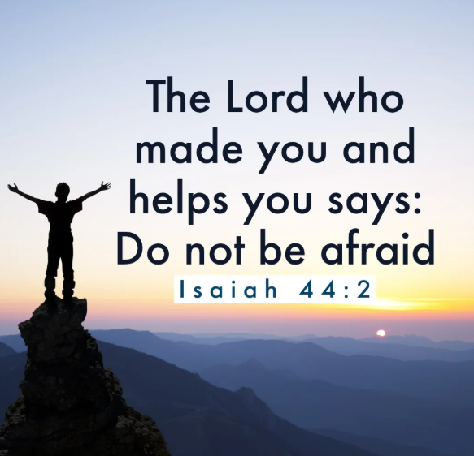
SCRIPTURE READING
Isaiah 44:1-4

Liturgist:
This is the word of the Lord.

People: Thanks be to God.

PRAYER
THE LORD’S PRAYER
OFFERTORY

DOXOLOGY “Praise God, from Whom All Blessings Flow” Hymnal #95

SCRIPTURE LESSON Acts 2:34-39

MESSAGE Pastor Dan Gedman

CLOSING HYMN “Blessed Assurance” Hymnal #369

BENEDICTION

POSTLUDE

Assisting in Worship: Denise Quinn (Liturgist)/ Geoffrey & Nikki Young (Ushers)/ Elaine Orme & Barbara Little (Greeters)

Prayer Concerns

Pray for those in our parish & community needing healing and comfort:
Glenn & Elaine Orme, Sally Taylor, Goerge Miller, Mary Patrick, Laurie Swann, Stacie Bailey, Gary Wise, Mary Plumley, Kenzie MacLean, Jessica Eaton, Tim Lee, Shannon Hannawald, Kenny Wood, Don Smith, Chris Wright, Jimmy Tolson, Phyllis Frase, Christina Thomas, Francis Blazejak, Randy Bowen, Wendy Bradley, Bill Hughes, Cori Bennington, Randall Butler, Rosemary Ayers, Kurt Plinke, Mariah Farmer-Grace, Mitchell Griffith, John and Danielle Stewart, Robin, Dave & Jan Almquist, Carol & Lester, Courtney Harrison, Kitty Patrick, Craig Little, Baby Charlie, Suzanne Drury, Shawn Parks, and Evelyn.

Pray in Sympathy for the family and friends of those who have died, especially Jenny Eggers, Patrice Morrison, and Demair Lloyd.

Pray for those serving in the U.S. Military: Seth Gill, Gabe Griffith, Ethan Lister, Teagan Lister, Andrew Robbins, Jack Schroeder, Bryan Hatch, Brayden Boartes, and Cody Chambers.

This Week at St. Luke’s _____ _ _ _____ June 14th – June 21st
Sunday: 8:30 am & 10:00 am Worship
9:30 am – Adult Sunday School – Room 1
Thursday: 10:00 am – OMLG – Room 1
7:30 pm – Church Council – Room 1
Sunday: 8:30 am & 10:00 am Worship (Father’s Day)
9:30 am – Adult Sunday School – Room 1

Summer Office Hours (June – August) are Tuesday-Thursday, 8:30 am – 5:00 pm

Attendance & Stewardship
8:30 am: 50 10:00 am – 62
Offerings: $5,112.30

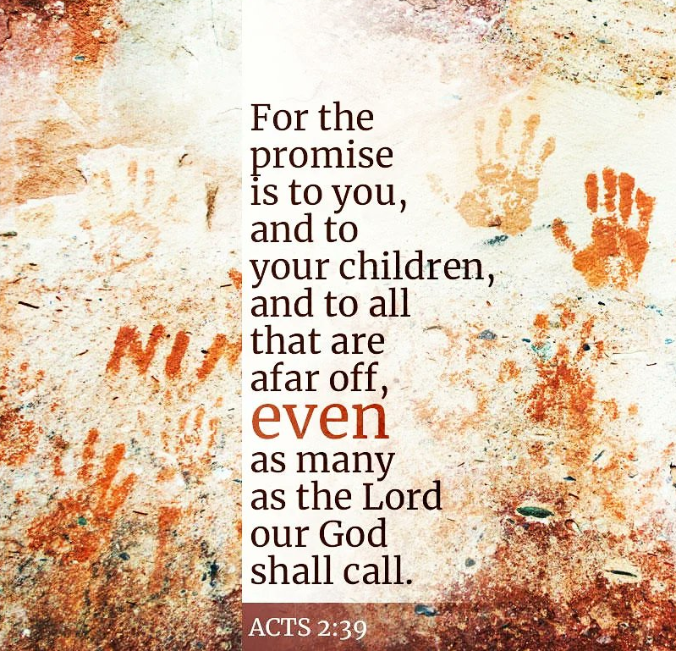


St. Luke’s Methodist Church
A Global Methodist Church

100 S. 5th Avenue, Denton, Maryland 21629

The Reverend Daniel Gedman, Pastor

Garrett Shull, Director of Youth Ministries
Carrie Soldano, Administrative Assistant
David Cherry, Music Director Traditional Service
Alicia Weippert, Director of Ignite Praise Band
Bruce Golt, Maintenance Manager
Alex Penn, Nursery Coordinator

Church Office: 410-479-2171
Pastor Dan: 443-693-3694
Email: stlukesdenton@gmail.com
Website: www.stlukesdenton.or

