ST. LUKE’S METHODIST CHURCH
Fifth Sunday after the Resurrection and Holy Communion

May 3rd, 2026 __________ __ ________8:30 am

If able, we stand to praise the Lord

PRELUDE

WELCOME & ANNOUNCEMENTS

CALL TO WORSHIP Psalm 34:1-3

I will extol the Lord at all times;
his praise will always be on my lips.
I will glory in the Lord;
let the afflicted hear and rejoice.
Glorify the Lord with me;
let us exalt his name together.

OPENING HYMN “Great Is the Lord” TFWS #2022
OPENING PRAYER

O God, you so loved the world as to give your only begotten Son,
that whosoever believes in him should not perish,
but have everlasting life.
Grant to us the precious gift of faith,
that we may know that the Son of God is come,
and may have power to overcome the world
and gain a blessed immortality;
through Jesus Christ our Lord. Amen.



SCRIPTURE READING
Colossians 3:12-15

Liturgist:
This is the word of the Lord.

People: Thanks be to God.

PRAYER
THE LORD’S PRAYER
OFFERTORY

DOXOLOGY “Praise God, from Whom All Blessings Flow” Hymnal #95

SCRIPTURE LESSON John 21:1-23

MESSAGE Pastor Dan Gedman

THE NICENE CREED Hymnal #880

HOLY COMMUNION (see insert)

HYMN “Spirit Song” Hymnal #347

BENEDICTION

POSTLUDE

Assisting in Worship: Jody Herb (Liturgist)/ Mitchell Griffith (Ushers)/ Gerry Glime & Lenore Retzolk (Greeters)

Prayer Concerns

Pray for those in our parish & community needing healing and comfort:
Jessica Eaton, Tim Lee, Shannon Hannawald, Kenny Wood, Paisley Grace, Don Smith, Howard Muir (and his family), Chris Wright, Bob Haught, Jimmy Tolson, Phyllis Frase, Christina Thomas, Francis Blazejak, Darren Cohee, Randy Bowen, Wendy Bradley, Bill Hughes, James & Wendy Miller, Cori Bennington, Randall Butler, Mary Hawkins, Rosemary Ayers, Glenn & Elaine Orme, Kurt Plinke, Mariah Farmer-Grace, Mitchell Griffith, John and Danielle Stewart, Robin, Dave & Jan Almquist, Carol & Lester, Courtney Harrison, Bryan & Addy Flaherty, Kitty Patrick, Craig Little, Baby Charlie, Emily Parry, Suzanne Drury, Mary Grace Cheezum, Shawn Parks, Ryan Alexander, Evelyn, and Jason Lee.

Pray in Sympathy for the family and friends of those who have died, especially Dr. Hilliard Gardner and his daughter, Allison Gardner, Tressie Reger, Jacki Poore, Richard Miller.

Pray for those serving in the U.S. Military: Seth Gill, Gabe Griffith, Ethan Lister, Teagan Lister, Andrew Robbins, Jack Schroeder, Bryan Hatch, Brayden Boartes, and Cody Chambers.

This Week at St. Luke’s _____ _ _ _______May 3rd - May 10th
Sunday: 8:30 am & 10:00 am Worship - Communion
9:30 am – Adult Sunday School – Room 1
9:45 am – Sunday School – Gather in the Sanctuary
Monday: 10:00 am & 7:00 pm – Bible Study – Room 1
Office Closed
Wednesday: 10:00 am – Cards of Comfort – Hospitality Room
Thursday: 10:00 am – OMLG – Room 1
6:30 pm – National Day of Prayer – Caroline County Courthouse
Saturday: 9:00 am – Emmaus Prayer & Fellowship – Hospitality Room
Sunday: 8:30 am & 10:00 am Worship (Confirmation)
9:30 am – Adult Sunday School – Room 1
9:45 am – Sunday School – Gather in the Sanctuary

Attendance & Stewardship
8:30 am – 47 10:00 am – 65
Sunday School Children: 39 Adults: 10
Offerings: $3,013.18

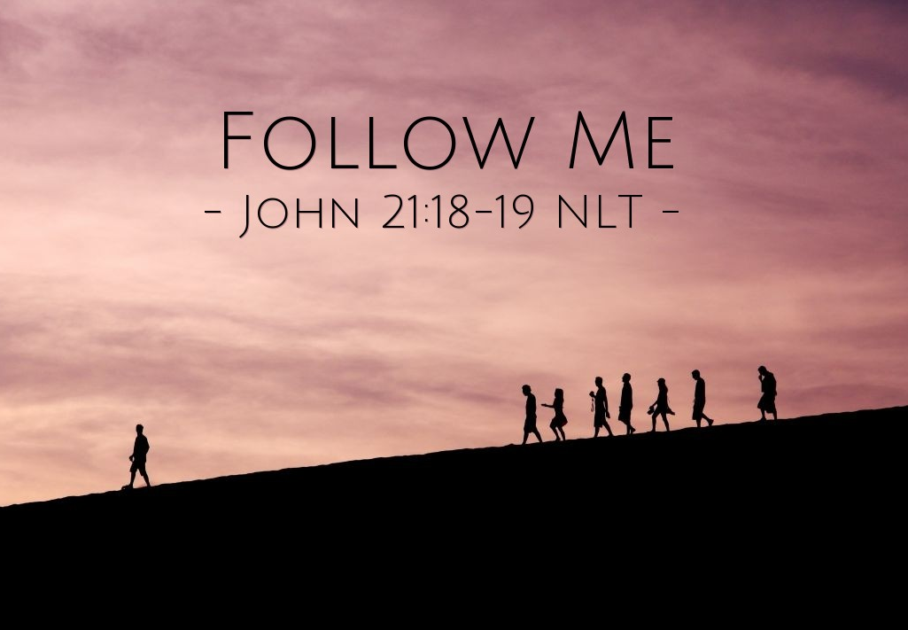


St. Luke’s Methodist Church

A Global Methodist Church

100 S. 5th Avenue, Denton, Maryland 21629

The Reverend Daniel Gedman, Pastor

Garrett Shull, Director of Youth Ministries
Carrie Soldano, Administrative Assistant
David Cherry, Music Director Traditional Service
Alicia Weippert, Director of Ignite Praise Band
Alex Penn, Nursery Coordinator
Bruce Golt, Maintenance Manager

Church Office: 410-479-2171
Pastor Dan: 443-693-3694
Email: stlukesdenton@gmail.com
Website: www.stlukesdenton.or

