Assisting in Worship: Tom Connar (Liturgist); Marie Stewart & Rosalind Parker (Ushers); Patty Thomason and Rhonda Bounds (Greeters)

Prayer Concerns:

Pray for those in our parish & community needing healing and comfort:
Jim Bilbrough, Burt Wheedleton, Dylan Nagel, Glenn & Elaine Orme, Kurt Plinke, Jennifer Shull, Mariah Farmer-Grace, Mitchell Griffith, John and Danielle Stewart, Brenda Hayman, Ziggy Zurek-Wellen, Robin, Dave & Jan Almquist, Carol & Lester, DCDC, Courtney Harrison, Bryan & Addy Flaherty, Jimmy Tolson, Kitty Patrick, Craig Little, Barbara Lawrence, Baby Charlie, John Webster, Emily Parry, Suzanne Drury, Mary Grace Cheezum, Shawn Parks, Ryan Alexander, Evelyn, and Jason Lee.

Pray for persecuted Christians in Nigeria and around the world, and for missionaries in Nigeria like Michell Harper, all who stand firm in their faith despite facing suffering and loss.

Pray in Sympathy for the family and friends of those who have died, especially the Collins sisters and Jack Sheets.

Pray for those serving in the U.S. Military: Seth Gill, Gabe Griffith, Ethan Lister, Teagan Lister, Andrew Robbins, Jack Schroeder, and Bryan Hatch.

This Week at St. Luke’s ____ ___________ Feb. 8th – Feb. 15th
Sunday: 8:30 am & 10:00 am – Worship Services
9:30 am – Adult Sunday Class – Room 1
9:45 am – Sunday School – Gather in Sanctuary
Monday: 10:00 am & 7:00 pm – Bible Study – Room 1
Wednesday: 7:00 am – 4:00 pm Resource Day (whole building)
7:00 pm – Praise Band Practice – Fellowship Hall
Thursday: 10:00 am – Old Men and Ladies Group– Room 1
11:00 am – 6:00 pm Blood Bank – Fellowship Hall
Saturday: 9:00 am – Emmaus Prayer & Fellowship – HR
5:00 pm – YG Valentines Supper (for parents) – FH
Sunday: 8:30 am & 10:00 am – Worship Services
9:30 am – Adult Sunday Class – Room 1
9:45 am – Sunday School – Gather in Sanctuary

Attendance & Stewardship Last Week
8:30 am: 38 10:00 am: 64
Sunday School Students: 48 Adults: 6
Offerings: $4,705.00


Welcome to

igni e
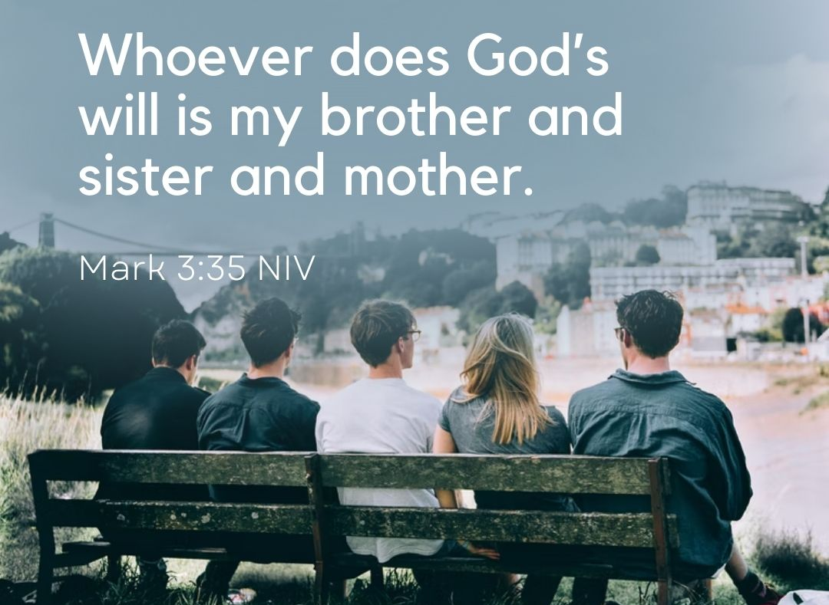

February 8th, 2026
5th Sunday after the Epiphany

Welcome and Announcements

Opening Prayer

Opening Worship

Pastoral Prayer & The Lord’s Prayer

Offering & Doxology

Holy Baptism of Morgan Demir

Scripture Lesson: Mark 3: 20-35

Message – Pastor Dan Gedman

Closing Worship

Blessing and Sending Forth

